**Earthquake Resistant Design_________________________________________________________________**

**Project 1: Modelling of an existing structure designed according to EC8 for low and high-intensity vibrations [Oct 2021 – Jan 2022]**

The dynamic behaviour of an already existing four-storey R.C. building is analyzed for low and high-intensity vibrations using a commercial modelling software Midas Gen. The structure has been tested using the pseudo-dynamic technique in the ELSA Laboratory of the Joint Research Center at Ispra (Italy) and the results of the numerical and experimental results are compared.

Knowledge and experience acquired:

* In-depth understanding of modelling frame structures, static, dynamic, and non-linear static and seismic analysis.
* Utilizing commercial structural analysis programs to verify results from experimental outcomes.

Software tools: Midas Gen, MS-Excel, AutoCAD

|  |  |
| --- | --- |
| Diagram  Description automatically generated  Figure 1. FEM model of four story building | Figure 2. Ground acceleration  Figure 3. Response spectrum |

Figure 4. Pushover capacity curve Vs experimental result

**Project 2: Seismic analysis and design of B+G+7 residential R.C. building [Oct 2021 – Jan 2022]**

A new B+G+7 reinforced concrete building was designed for a medium ductility class (DCM) and soil type C, according to EC2, EC8, NTC18 requirements and national annex recommendation. Response spectrum analysis was performed to analyse the model for the seismic action. After the design choice and all procedural computations are performed, the detailed reinforcement design of the beams, columns, shear walls and cores are prepared.

Knowledge and experience acquired:

* A good knowledge of the codes of practice and International Codes.
* Preliminary structural design parameters framing layouts, material, and construction specifications in accordance with Eurocode (EC) and Italian standard (NTC18).
* Performing structural analysis and design of building components (beams, columns, shear walls and cores) according to Eurocodes requirements.
* Utilizing structural analysis finite element program to verify results from hand calculations.
* Generating detailed technical drawings using AutoCAD.
* Writing ad-hoc numerical codes on MS-Excel and Python to streamline processes, save time and increase accuracy in repetitive tasks.
* Evaluating priorities and organizing individual workloads to meet tight project deadlines.

Software tools: Midas Gen, AutoCAD, Python, MS-Excel

|  |  |
| --- | --- |
| Diagram  Description automatically generated  Figure 5. FEM model of the structure | Shape  Description automatically generated  A picture containing building  Description automatically generated  Figure 6. Mode 1 vibration mode of the structure |
| Graphical user interface, application  Description automatically generated  Figure 7. Horizontal design response spectrum | Diagram  Description automatically generated with medium confidence  Figure 8. Mode 2 vibration mode of the structure |
| Diagram, schematic  Description automatically generated  Figure 9. Bending moment diagram of the structure | Figure 10. Mode 3 vibrational mode of the structure |

**BIM Fundamentals and applications__________________________________________________________**

Knowledge and experience acquired:

* Coordinate Conceptual, Architectural, Structural and Federated model of G+1 residential building.
* Drawing production, quantity take-off, scheduling, clash detections and reporting.

Software tools: Autodesk Revit

|  |  |
| --- | --- |
|  |  |
|  |  |

**Computational Structural Analysis (Feb 2021 – July 2021) _________________________________________**

**Project 1: Developed 2D frame program to assess the serviceability state of Railway bridge with Gerber joints.**

A case study of the Gerber joint railway bridge is analyzed. The structural analysis of a simplified structural model is performed using the frame program that is developed as part of this project. Results from the structural analysis are then compared with field test deflection measurement using the three methodologies, under certain loading combinations. Finally, the developed program was able to provide a reliable result in terms of the quantitative load testing measurement. Moreover, the preliminary result of the structural modelling is also further used to improve the model aimed to reduce the relative error of the solution.

* Software tool: FORTRAN, MATLAB and MS-Excel

Figure 11. Railway bridge with Gerber Joint

Figure 12. Structural scheme of the bridge

Figure 13. Structural model (a) Gerber joints modeled with hingeDiagram

Description automatically generated

Figure 14. Structual model (b) Gerber joints modeled with roller

**Project 2: Developed Isoparametric (ISOP4) FE program to study the response behaviour of Deep beams**

This four node isoparametric element (ISOP4) based code was developed to study the structural response of the so-called discontinuity regions or “D-regions”.

|  |
| --- |
| Diagram  Description automatically generated  Figure 15. Geometry and loading condition of the structure |
| Figure 16. Diagram of normalized stress for varying a/b ratio |

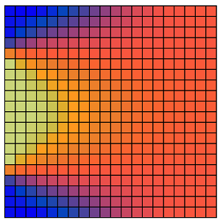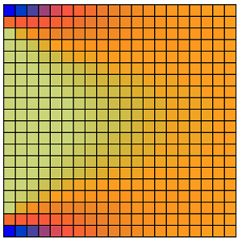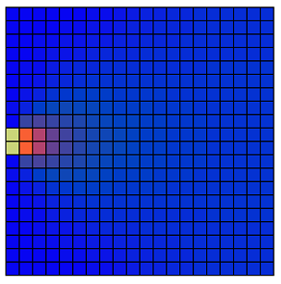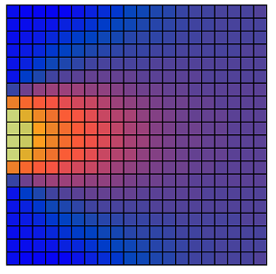

Case: a/h = 0

Case: a/h = 0.3

Case: a/h = 0.6

Case: a/h = 0.9

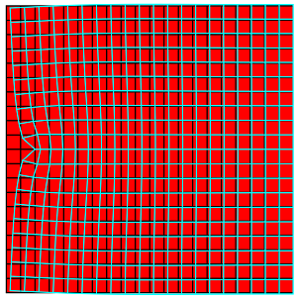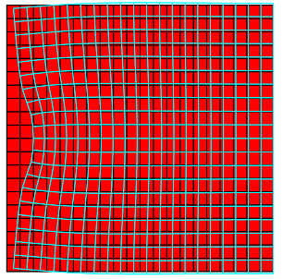

Case: a/h = 0

Case: a/h = 0.3

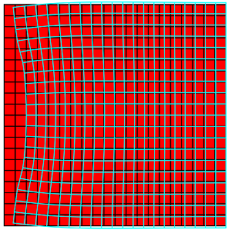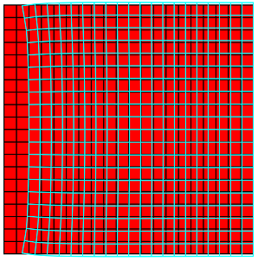

Case: a/h = 0.6

Case: a/h = 0.9

Figure 17. Deformed shape of different a/h ratio

Figure 18. Normal stress of different a/h ratio